***Spring and fall acoustics surveys***

In the NL region, the capelin stock has been surveyed using acoustic methods since the 1980s [see Mowbray (2014) for more details]. From 1982 to 1993 there were two acoustic surveys annually that initially targeted what was thought to be two separate stocks (Div. 2J3K and Div. 3L) (Campbell and Winters 1973); however, meristic (Misra and Carscadden 1984) and tagging studies (Nakashima 1992) supported one single stock unit in NAFO Div. 2J3KL. Following the change in stock definition, the two acoustic surveys targeted different life stages of the stock. Spring acoustic surveys in May targeted the immature portion of the stock in NAFO Div. 3L. This survey provided an abundance estimate of immature capelin that will be recruiting into the fishery the following year. The second acoustic survey was conducted in October in NAFO Div. 2J3K that targeted the maturing portion of the stock to provide a revised estimate of the size and number of maturing fish recruiting to the fishery the following year. The dramatic decline in the spring acoustic estimate in 1991, which was not reflected in the inshore indices (Carscadden and Nakashima, 1997), instigated dropping the spring survey in favour of an expanded fall survey (NAFO Div. 2J3KL) in 1993-1994. However, this expanded fall acoustic survey did not find the ‘missing’ capelin biomass and reconcile the inshore and offshore indices. The fall survey was subsequently cancelled and the spring acoustic survey in NAFO Div. 3L has been conducted annually since 1996 (except in 1997, 1998, 2006 and 2016).

The acoustic survey design and implementation has changed significantly over time and a more detailed description of the acoustic survey program is provided in Mowbray (2014). The current spring acoustic survey consists of a series of equidistant parallel transect lines every 15 to 30 nautical miles with survey effort being partitioned amongst a number of strata that were classed as core (e.g., highest priority) or non-core (e.g., lowest priority). The position of the initial transect line is randomly determined while the positions of subsequent lines are dependent on the position of the initial line. Targeted fishing sets were conducted to determine the species composition of the acoustic backscatter. Additional fishing sets were conducted periodically to confirm the absence of fish signal with at least one fishing set conducted every 12 hour period during all surveys. Prior to 1996, a large mid-water trawl (Diamond IX) was used to collect biological samples. Since 1996, both mid-water (IYGPT) and bottom trawls (Campelen 1800) have been used to collect samples. Set duration ranged from 15 to 120 minutes depending on mode of deployment and the intensity of the backscatter to be verified. Detailed sex-length stratified biological sampling of capelin, including age, length, weight, maturity, diet, is conducted annually.

*Spatio-temporal mismatch post-1991*

Frank et al. (2016) hypothesized that delays in the timing of capelin spawning post-1991 may have led to a mismatch in capelin availability to the acoustic survey. However, due to the age-dependent distribution of capelin with older capelin in the north (Div. 2J3K) and immature capelin in the south (Div. 3L), the spring acoustic survey in NAFO Div. 3L was only ever designed to survey the immature portion of the stock rather than the spawning migration. Specifically, the spring acoustic survey provides an index of abundance of the immature age-2 portion of the stock, as age-1 capelin have a weak acoustic signal and are only detected when they are present in large numbers at high densities. Age-1 capelin are also poorly recruited to the sampling gears, resulting in an underestimation of their overall contribution to the acoustic signal. The proportion of maturing age-2 capelin has increased post-1991 (varies annually between 37-79% compared to 4% pre-1991) (Mowbray 2014), and this change in biology may have introduced a bias in the acoustic survey post-1991 by artificially depressing the immature capelin acoustic estimate, which relies solely on age-2 fish. However, the acoustic survey has had high internal consistency, with the abundance of the age-3 cohort highly correlated (R2=0.98, P<0.001) with the abundance of the age-2 cohort of the previous year. Cohort tracking in the acoustic survey failed in only two years (1990 and 2010), which affected all ages rather than just the age-2 and age-3 cohorts (Mowbray 2014).

For spawning capelin, there is a spatio-temporal mismatch between spawning migrations and the spring acoustic survey due to persistently later spawning post-1991. Moreover, if mature capelin are present in the area, they are unlikely to be detected due to highly aggregated shoals relative to the survey effort. Capelin surveys in other countries are timed to avoid spawning migrations (Gjosaeter 1998). An exception is Iceland, where if capelin are not detected in surveys during the fall feeding period due to shifting stock distribution, follow-up surveys are conducted during spawning migrations (reviewed in Carscadden et al. 2013). In recognition of the difficulty involved in locating highly aggregated spawning shoals within a large expanse of water, Iceland increases their survey efforts for spring spawning migrations and utilizes commercial fleet information to exclude survey areas with no capelin, allowing the survey vessels to conduct a more concentrated survey for highly aggregated shoals of migrating capelin. This level of survey effort is not possible during the spring survey in the NL region resulting in these migratory spawners rarely being intercepted (Fig FM-3). However, when concerns were raised in the region that the spring acoustic survey may be missing capelin due to a change in spawning timing, repeat acoustic surveys in June of 1991 and 2003 were conducted (Mowbray 2014). These repeat surveys failed to detect a marked change in capelin biomass between survey months (Mowbray 2014). A delay in migration timing also does not explain the coincidental sudden decline of capelin in the fall acoustic surveys starting in 1990, a year when spawning timing was normal (Fig FM-4). Consequently, we find no evidence that the persistent delay in the spawning migration of capelin post-1991 is responsible for creating an illusion of a sudden and sustained loss of capelin in the spring acoustic surveys conducted by Canada and the USSR. The offshore spring and fall acoustic surveys support the hypothesis of a capelin collapse.

*Capelin stock is non-migratory and inshore post-1991*

Frank et al. (2016) suggested that an alternate explanation to the apparent offshore acoustic survey collapse was an abrupt change in capelin migration patterns post-1991, with capelin now remaining inshore year round. The migration hypothesis postulates that a non-migratory capelin stock post-1991 will mature at an earlier age (Frank et al. 2016). To test this hypothesis, we examined trends in capelin maturity from 1982-2015 using data from the spring acoustic survey with capelin partitioned into spatial strata based on both depth and latitude. Annually, the fraction of capelin in each age-class and strata that were classed as mature were divided by the total number of capelin from that age-class. There were a number of changes in capelin maturation trends from 1982-2015. Prior to 1991, ~7% of age-2 and ~58% of age-3 capelin were classed as mature and there was substantial variability in the fraction of individuals within an age-class that were mature in a particular year. At age-4, nearly all capelin were classed as mature on a consistent basis. Between 1991 and 1999, data on capelin maturity was sparse, but from the limited data that were available, it appears that there was a general increase in the percentages of ages-2 and 3 that were mature. From 2000-2010, 57% age-2 and 99% age-3 were mature, which was a significant increase from 1982-1990. Since 2010, the proportion of mature age-2’s declined substantially to 40% and the proportion of mature age-3’s experienced a smaller decline to 93%.

While our analysis on maturity pre- and post-1991 is consistent with Frank et al. (2016)’s hypothesis that a capelin population that is no longer migrating will have a younger age at maturity, our results are also consistent with the hypothesis that age at maturity will decline in fish populations that are stressed (Trippel 1995), with a stressed population being defined by Shuter (1990) as “one that has undergone a substantial decline in size”. Furthermore, it is possible to see rapid changes in age at maturity in response to shifts in stock size (Trippel 1995); for example, as Atlantic herring stocks increased in the mid-1980s in the Gulf of St. Lawrence, there was a 50% decrease in the percentage of mature age-3 Atlantic herring (Melvin et al. 1995). There has been a similar response recently in NAFO Div. 2J3KL with a recent decline in the fraction of mature ages-2 and -3 capelin since 2010, which corresponded with a recent increase in capelin biomass.

Younger ages at maturity have a number of potentially negative implications for capelin biomass that challenge Frank et al. (2016)’s migration hypothesis. Male capelin are essentially semelparous, with typically one reproductive period before dying, while females are iteroparous, reproducing in multiple years (Huse, 1998). A shift towards earlier maturation post-1991, with most capelin being mature by age-3, has resulted in a substantial reduction in the number of age-4 male capelin. The reduction in the number of age-4 males impacts age-4 females because, if all other factors remain equal, age-4 females will experience a greater share of predation pressure due to there being fewer age-4 males available to absorb predation. Maturing at a younger age requires capelin to divert energy away from somatic growth towards developing gonads. This results in consistently smaller capelin across age-classes (Carscadden, Frank, & Leggett, 2001) and has an additional effect of reducing the number of eggs that an individual female can produce as the number of eggs produced is related to mass with capelin that have higher masses producing more eggs than capelin with lower masses (Penton & Davoren, 2013). These factors are likely to result in a reduction in capelin biomass.

*Trophic cascade*

A decrease in groundfish biomass, specifically northern cod, in 1991 should have resulted in a rapid increase in capelin biomass due to a trophic cascade (Frank et al. 2005). Regions where there was a rapid increase in capelin biomass in response to a decline in cod biomass (Frank et al. 2016), the decline in cod biomass was due to overfishing rather than a broader ecosystem effect. In these cases, it is quite straightforward that a decline in predator biomass leads to an increase in prey biomass. This was not the case in the 1990-1991 collapse of capelin, cod and a number of other finfish species in the NL region. Several species were simultaneously negatively affected by a common environmental factor. As Frank et al. (2016) note, “it is possible that capelin availability had not declined relative to the diminished cod biomass” suggesting capelin in NL in 1990-1991 did not experience a predation release. On the other hand, shellfish biomass increased post-1991, likely due to a release from predation and favourable environmental conditions following the finfish collapse (Lilly et al. 2000; Worm and Myers 2003).

To investigate the effect of northern cod decline on capelin mortality, we developed an index of total mortality from the spring acoustic survey from 1982-2015. Annual estimates of abundance by age-class were rearranged to create a time series of abundance estimates for cohorts that were spawned from 1977 to 2013. For each cohort, we solved the exponential decay function

$$N_{t+1}=N_{t}e^{-Z}$$

for *Z*, an index of the total mortality between subsequent estimates of abundance (~1 year), for each pair of consecutive age-classes within a cohort. *Z* is an index of the total mortality rate rather than an estimate of total mortality as not all age-classes are fully recruited to the acoustic survey (this can be seen by the cases where *Z* is negative), differences in spatial coverage and trawling effort between surveys, and differences in spatial overlap between the area surveyed and the spatial distributions of the different age-classes of capelin are not accounted for. Other variables in the equation were *N*, the abundance of capelin in an age-class; *t* the age-class of interest; and *t* + 1 is the subsequent age-class. The indices of total mortality for cohorts over time were then rearranged in order to produce time-series plots of the index of total mortality over time by transition group (e.g., age-2 to age-3, age-3 to age-4) (Figure). The data were aligned so that the indices of total mortality are shown for the year in which the *t* + 1 age-class was surveyed. The age-1 to age-2 transition group is not shown as age-1 capelin were not fully recruited to the trawl. The indices of total mortality for 2010 and 2011 are suspect as most extant cohorts at that time had very low abundances in 2010 and much higher abundances in 2011 resulting in high index of total mortality values in 2010 and very low (negative) index of total mortality values for 2011.

Trends in the time-series for the index of total mortality are complicated by the variability in the index across years and large data gaps. There is a clear increase in the index of total mortality across transition groups in 1991 corresponding to the broad-scale die off of capelin between 1990 and 1991. As noted previously, a second large increase in the total mortality index occurs in 2010, which is probably due to the failure of the 2010 survey. Due to the variability in the time series, the problems with the index values for 2010 and 2011, and large gaps in the time-series, the total mortality index values were grouped for the periods 1983-1990, 2000-2005 and 2008-2015, excluding 2010 and 2011 (Table XX). The mean value for the index of total mortality for each transition group was higher for the 2000-2005 and 2008-2015 time periods than it was for the pre-1991 time period (TableXX). This suggests that rather than experiencing a predator release post-1991, capelin experienced higher mortality since the collapse of one of its main predators. There are at least four potential non-exclusive explanations as to why the index of total mortality has increased over time. First, while capelin biomass has declined to ~1/6th of the biomass observed between 1985 and 1990 the inshore commercial catch of capelin has declined by a bit more than half which would result in an increase in the fishing mortality experienced by capelin. Second, capelin post-1991 are smaller than capelin pre-1991, and in general, smaller fish experience higher predation mortality rates than larger fish (Gislason, Daan, Rice, & Pope, 2010; Sogard, 1997). Third, with an earlier age at maturation, younger age classes of capelin are experiencing higher rates of mortality due to mortality associated with reproduction (Huse, 1998). Fourth, there may have been a shift in the spatial distribution of capelin that has resulted in a systematic increase in the index of total mortality (e.g., Frank et al. 2016).

***Fall multispecies bottom trawl survey***

Fall multispecies bottom trawl surveys (FBTS) have been conducted in NAFO Div. 2J3KL from 1978. The FBTS is a random depth-stratified sampling design with trawls of fixed duration and speed. From 1978-1994, trawls were conducted using an Engel otter trawl. In 1995, the FBTS switched to using the smaller mesh size Campelen 1800 shrimp trawl, and the trawls were adjusted to a slower speed and shorter duration to account for larger catches. The change in trawls in 1995 increased the catchability of small fish species, like capelin, in the FBTS. With the cancellation of the fall acoustic survey, the FBTS is the only source of data on the distribution and presence/absence of maturing capelin in the fall in NAFO Div. 2J3KL. There is a concordance in the multi-year trends of age-dependent capelin distributions in the FBTS and the spring acoustic survey (Fig FM2), with a latitudinal cline in age composition in the FBTS with the youngest capelin in the south (Div. 3L) and the older ages more prevalent in the north (Div.2J3K).

In addition to changes in the trawl in 1995, ecosystem and behavioural changes in capelin post-1991 improved capelin’s catchability in the FBTS. Capelin were sampled closer to the seabed when cod were not present, and as cod abundance declined in the late 1980s, the proportion of capelin biomass in the trawl zone (bottom 4 m of the water column) increased (Mowbray 2002). Furthermore, when capelin densities were low, capelin were found in closer association with the bottom and displayed less vertical behaviour compared to when capelin densities were high (Mowbray 2002). This change in a pelagic fish’s vertical behaviour was also seen in Atlantic herring in the Gulf of St. Lawrence where in the absence of Atlantic cod predation, Atlantic herring moved into the suprabenthic zone and increased their availability to the bottom trawl despite declines in abundance (McQuinn 2009). These changes in vertical distribution are a cause for concern for acoustic surveys, as acoustic surveys are unable to resolve targets on or near the seabed, also known as the bottom deadzone (Ona and Mitson). The height of the deadzone is a function of the pulse length and frequency of the acoustic system used, and the bottom deadzone was approximately 0.75 m for the capelin spring acoustic surveys. In order to address the potential impact of vertical distribution changes on the availability of capelin to the acoustic surveys, dedicated experiments were carried out in 1995 and 1999 (Mowbray 2002). The range of values for diel changes in capelin detectability obtained from these experiments were used in the calculation of confidence estimates for each survey since 1988 using a Monte Carlo simulation. Confidence estimates indicate a significant decline in capelin biomass between the late 1980s and 1991 (Fig FM-9).

*Capelin stock is non-migratory and inshore post-1991*

Frank et al. (2016) hypothesized that there was an abrupt change in capelin migration patterns post-1991, with capelin now remaining inshore year round. As evidence for this hypothesis, they used the FBTS data to point to a westerly, inshore shift in the center of capelin concentration in 1996-2010 compared to 1985-1995. However, their own annual mapping demonstrates the high degree of interannual variability in capelin abundance within the earlier period (1985-1995), with inshore distributions occurring in three high abundance years (1986-1988, Fig S2 Frank et al. 2016). We were interested in testing this main hypothesis from Frank et al. (2016) using multiple approaches [e.g., triangulation; Munafo and Smith (2018)] in order to compare results from independent datasets (e.g., spring acoustic survey, FBTS, inshore fishery data) using diverse statistical methods to either support or dismiss the capelin inshore migration hypothesis. To test this migration hypothesis using the FBTS data, we used the center of gravity approach described in Thorson et al. (2016). Specifically, we used the VAST package in R (Thorson et al. 2017) to fit a geostatistical delta-generalized linear mixed model to estimate the spatial and temporal distribution of capelin. The main advantage of this approach is that it accounts for changes in the spatial distribution of sampling effort from one year to the next. This method also provides a means of estimating the standard error of the center of gravity metric, which provides a perspective on the significance of distributional shifts. This geostatistical analysis did not support the hypothesis that capelin have shifted their distribution towards the inshore post-1991 with no evidence of an easterly or westerly movement in the centre of gravity of capelin (Figure x). Instead, the center of gravity of capelin shifts northward as abundance increases and southwards as abundance decreases (Figure x). More basic analyses also indicate that it is unrealistic that 3 to 6 Mt of capelin are residing in the inshore. The ‘blind-spot’ of the FBTS is between ~35,000 to ~71,000 km2, depending on whether the inshore strata are counted or not. The minimum density of 3 to 6 Mt of capelin in these inshore waters would have to be between ~41,000 to ~170,000 kg / km2. The maximum mean density of capelin observed in Trinity Bay survey strata in June, which corresponds with the start of the spawning period when capelin are highly aggregated inshore, was 10,000 kg / km2 (Table X). Maximum mean density of capelin observed outside the spawning period was only 40 kg / km2 (Table X). Neither observation can account for the required amount of capelin hypothesised to be residing inshore if there was no collapse of capelin in the NL region. Therefore, the FBTS supports the capelin collapse hypothesis.

***Inshore commercial capelin fishery***

*Capelin stock is non-migratory and inshore post-1991*

Annual age composition data from the spring acoustic survey and the inshore commercial capelin fishery using all fishing gears (purse, beach and tuck seines, and traps) in NAFO Div. 3KL were used to test Frank et al. (2016)’s hypothesis that capelin are no longer migratory post-1991. If capelin had stopped migrating offshore in the fall, we would expect to see fewer, older capelin in offshore waters compared to inshore waters. We found that there were large shifts in capelin age compositions from 1980-2016. Prior to 1991, ~97% of the spring acoustic survey catches were composed of ages 2, 3, 4. Post-1991, contributions of ages-2, 3 have remained consistent at ~60% and ~28% of the catch, respectively, while age-1 capelin has gone from being 1% of the catch to ~10% of the catch and contributions of ages-4, 5, 6 have declined. In the inshore commercial fishery pre-1991, ~96-99% of the catches in NAFO Div. 3KL consisted of ages 3, 4, 5 with age-2 capelin comprising 0.6 - 3.4% of total catch. Post-1991, the 3 oldest age-classes of capelin (ages 4, 5 and 6) all experienced severe declines with the 2 oldest age-classes effectively disappearing form the inshore commercial fishery. Age-2 capelin averaged 32% (60-fold increase) of the catch in Div. 3K and 42% (12-fold increase) of the catch in Div. 3L, while the contribution of age-3 fish to commercial inshore catches has been relatively unchanged.

The decrease in numbers of older capelin being caught in the spring acoustic survey supports Frank et al. (2016)’s migration hypothesis. However, the lack of a corresponding increase in the numbers of older capelin caught in the inshore commercial fishery, where their numbers have actually decreased both in absolute terms and as a proportion of the overall catch, supports the rejection of the migration hypothesis. The truncation of the age-structure of capelin in both inshore and offshore waters and a subsequent shift to younger age-classes does support Fisheries and Oceans Canada findings that the capelin population in NAFO Div. 2J3KL has collapsed relative to the 1980s and has not yet recovered.

Discussion points:

With the increase in the total mortality index over time, it seems quite plausible that capelin numbers have remained low since 1990-91 due to a combination of several factors:

1. Not having experienced a release from predation mortality following the collapse of cod
2. Experiencing an increased rate of fishing mortality due to allowable catches not being reduced by an amount proportionate to the decline in capelin biomass following the collapse in 1991
3. Unchanged and/or increased predation pressure from species that were either unaffected by or less affected by the factors that caused a finfish collapse in 1990-91 and who subsequently recovered or expanded in biomass
4. Increased competition for food from species that have similar prey preferences

For capelin biomass to return to its historic levels may require reductions in fishing or predation mortality and improved ocean conditions.

Table XX Mean index of total mortality by transition group for the periods 1983 to 1990, 2000 to 2005 and 2008 to 2015 with the exclusion of 2010 and 2011.

|  |  |  |  |
| --- | --- | --- | --- |
| Transition group | 1983 to 1990 | 2000 to 2005 | 2008 to 2015  excludes 2010, 2011 |
| Age 2 to 3 | 0.50 | 1.1 | 0.87 |
| Age 3 to 4 | 1.1 | 1.8 | 2.3 |
| Age 4 to 5 | 1.7 | 2.3 | 2.6 |
| Age 5 to 6 | 2.0 |  |  |

## References

Alheit J, Roy C, Kifani S (2009) Decadal-scale variability in populations. In: Checkley D, Alheit J, Oozeki Y, Roy C (eds) Climate Change and Small Pelagic Fish. Cambridge University Press, Cambridge, UK

Buren AD, Koen-Alonso M, Pepin P, Mowbray F, Nakashima BS, Stenson GB, Ollerhead N, Montevecchi WA (2014) Bottom-up regulation of capelin, a keystone forage species. PLoS ONE 9:e87589

CAMPBELJL. , S., AND G. H. WINTERS1. 1973. Some biological characteristics of capelin, ***Mullotus vilkosus,*** in the Newfoundland area. ICNAF Wedb.1973(III): 137-144.

Carscadden JE, Frank KT, Leggett WC (2001) Ecosystem changes and the effects on capelin (*Mallotus villosus*), a major forage species. Canadian Journal of Fisheries and Aquatic Sciences 58:73-85

Carscadden JE, Gjøsæter H, Vilhjálmsson H (2013) A comparison of recent changes in distribution of capelin (*Mallotus villosus)* in the Barents Sea, around Iceland and in the Northwest Atlantic. Progress in Oceanography

Carscadden JE, Nakashima BS (1997) Abundance and changes in distribution, biology and behavior of capelin in response to cooler water of the 1990s. Forage fishes in marine ecosystems Proceedings of the International Symposium on the Role of Forage Fishes in Marine Ecosystems Alaska Sea Grant College Program Rep No AK-SG-97-01. University of Alaska Fairbanks, Fairbanks, Alaska

Chavez FP, Ryan J, Lluch-Cota SE, Ñiquen MC (2003) From anchovies to sardines and back: multidecadal change in the Pacific Ocean. Science 299:217-221

Dalley EL, Anderson JT, deYoung B (2002) Atmospheric forcing, larval drift, and recruitment of capelin ( Mallotus villosus ). ICES Journal of Marine Science 59:929-941

DFO (1994) Report on the status of pelagic fishes (capelin off Newfoundland and in the Gulf of St. Lawrence, and herring off the East, Southeast and South coasts off Newfoundland). DFO Atlantic Fisheries Stock Status Report 1994/3

DFO (2008) Assessment of capelin in SA2+Div. 3KL in 2008. DFO Canadian Science Advisory Secretariat Science Advisory Report 2008/054

DFO (2010) Assessment of Capelin in SA 2 + Div. 3KL in 2010. DFO Canadian Science Advisory Secretariat Science Advisory Report 2010/090

DFO (2013) Assessment of capelin in SA2 + Div. 3KL in 2013. DFO Canadian Science Advisory Secretariat Science Advisory Report 2013/11

DFO (2015) Assessment of capelin in Subarea 2 and Divisions 3KL in 2015. DFO Canadian Science Advisory Secretariat Science Advisory Report 2015/036

Frank KT, Leggett WC (1981) Wind regulation of emergence times and early larval survival in capelin (*Mallotus villosus*). Canadian Journal of Fisheries and Aquatic Sciences 38:215-223

Fisher JAD, Frank KT (2004) Abundance-distribution relationships and conservation of exploited marine fishes. Mar Ecol ProgSer 279:201-213

Frank KT, Petrie B, Boyce D, Leggett WC (2016) Anomalous ecosystem dynamics following the apparent collapse of a keystone forage species. Marine Ecology Progress Series 553:185-202

Gjøsæter H, Bogstad B, Tjelmeland S (2009) Ecosystem effects of the three capelin stock collapses in the Barents Sea. Marine Biology Research 5:40-53

Gomes MdC, Haedrich RL, Villagarcia MG (1995) Spatial and temporal changes in the groundfish assemblages on the north-east Newfoundland/Labrador Shelf, north-west Atlantic, 1978-1991. Fisheries Oceanography 4:85-101

Grégoire F, Girard L, Beaulieu J-L, Lussier J-F, Bruneau, B. (2013) Capelin (Mallotus villosus) in the Estuary and Gulf of St. Lawrence (NAFO Divisions 4RST) in 2012. DFO Can. Sci. Advis. Sec. Res. Doc. 2013/023

Hammill MO, Stenson GB, Doniol-Valcroze T, Mosnier A (2011) Northwest Atlantic harp seals population trends, 1952-2012. DFO Canadian Science Advisory Secretariat Research Document 2011/099

Hutchings JA, Myers RA (1994) What can be learned from the collapse of a renewable resource? Atlantic cod, *Gadus morhua*, of Newfoundland and Labrador. Canadian Journal of Fisheries and Aquatic Sciences 51:2126-2146

ICES (2017) Report of the North Western Working Group (NWWG). Copenhagen, Denmark

Ingvaldsen RB, Gjøsæter H 2013 [Responses in spatial distribution of Barents Sea capelin to changes in stock size, ocean temperature and ice cover](http://www.tandfonline.com/doi/full/10.1080/17451000.2013.775450) [Marine Biology Research](http://www.tandfonline.com/toc/smar20/9/9)Vol. 9, Iss. 9, 2013

Jangaard PM (1974) The capelin (*Mallotus villosus*): biology, distribution, exploitation, utilization, and composition. Bulletin of the Fisheries Research Board of Canada 186:1-70

Kenchington, E. L., Nakashima, B. S., Taggart, C. T., & Hamilton, L. C. (2015). Genetic Structure of Capelin (*Mallotus villosus*) in the Northwest Atlantic Ocean. *PLoS ONE*, *10*(3), e0122315. http://doi.org/10.1371/journal.pone.0122315

Koen-Alonso M, Pepin P, Mowbray F (2010) Exploring the role of environmental and anthropogenic drivers in the trajectories of core fish species of the Newfoundland-Labrador marine community.

Leggett WC, Frank KT, Carscadden JE (1984) Meteorological and hydrographic regulation of year-class strength in capelin (*Mallotus villosus*). Canadian Journal of Fisheries and Aquatic Sciences 41:1193-1201

Lilly GR, Parsons DG, Kulka DW (2000) Was the increase in shrimp biomass on the northeast Newfoundland shelf a consequence of a release in predation pressure from cod? Journal of Northwest Atlantic Fishery Science 27:45-61

### McQuinn I (2009) Pelagic fish outburst or suprabenthic habitat occupation: legacy of the Atlantic cod (Gadus morhua) collapse in eastern Canada *Can J Fish Aquat Sci* 66:2256-262,<https://doi.org/10.1139/F09-143>

Miller DS (1994) Results from an acoustic survey for capelin (*Mallotus villosus*) in NAFO Divisions 2J3KL in the autumn of 1993. Capelin in SA2 + Div 3KL DFO Atlantic Fisheries Research Document 94/18

Miller DS (1997) Results from an acoustic survey for capelin (*Mallotus villosus*) in NAFO Divisions 3KL in the spring of 1996. Capelin in SA2 + Div 3KL DFO Atlantic Fisheries Research Document 97/29

MISRAR, . **K.,** AND J. **E.** CARSCADDE1N98. 4. Stock discrimination of capeiin

***(Mallotus villosus)* iit** the Northwest Atlantic. J. Northwest Atl. Fish. Sci.

5: 199-205.

Murphy HM, Pepin P, Robert D (2018) Re-visiting the drivers of capelin recruitment in Newfoundland since 1991. Fisheries Research 200:1-10

Nakashima, 5. S. 1992. Patterns **iw** coastal migration and stock structure of capelin (Mallotus villosus). Can. 1.

Fish. Aquat. Sci. 49: **2423-2429.**

Nakashima BS, Wheeler JP (2002) Capelin (*Mallotus villosus*) spawning behaviour in Newfoundland waters - the interaction between beach and demersal spawning. ICES Journal of Marine Science 59:909-916

Obradovich SG, Carruthers EH, Rose GA (2014) Bottom-up limits to Newfoundland capelin (Mallotus villosus) rebuilding: the euphausiid hypothesis. ICES Journal of Marine Science 71:775-783

O’Driscoll, R. L., Rose, G. A., and Anderson, J. T. (2002) Counting capelin: a comparison of acoustic density and trawl catchability. ICES Journal of Marine Science, 59:1062–1071.

Olafsdottir, A.H. and Rose, G.A. (2013) Staged spawning migration in Icelandic capelin (Mallotus villosus): effects of temperature, stock size and maturity. Fisheries Oceanography, 22: 446-458.

Olafsdottir, A.H. and Rose, G.A. (2012) Influences of temperature, bathymetry and fronts on spawning migration routes of Icelandic capelin (Mallotus villosus). Fisheries Oceanography, 21: 182-198.

Ona, E and Mitson (1996)

Pálsson ÓK, Gislason A, Guðfinnsson HG, Gunnarsson B, Ólafsdóttir SR, Petursdottir H, Sveinbjörnsson S, Thorisson K, Valdimarsson H (2012) Ecosystem structure in the Iceland Sea and recent changes to the capelin (Mallotus villosus) population. ICES Journal of Marine Science 69:1242-1254

Pedersen EJ, Thompson PL, Ball RA, Fortin M-J, Gouhier TC, Link H, Moritz C, Nenzen H, Stanley RRE, Taranu ZE, Gonzalez A, Guichard F, Pepin P (2017) Signatures of the collapse and incipient recovery of an overexploited marine ecosystem. Royal Society Open Science 4

Pikitch EK, Boersma PD, Boyd IL, Conover DO, Cury PM, Essington TE, Heppell SS, Houde ED, Mangel M, Pauly D, Plagányi E, Sainsbury KJ, Steneck RS (2012) Little fish: big impact: managing a crucial link in ocean food webs. Lenfest Ocean Program, Washington, DC

Rice J (2002) Changes to the large marine ecosystem of the Newfoundland-Labrador shelf. In: Sherman K, Skjoldal HR (eds) Large marine ecosystems of the North Atlantic. Elsevier Science B.V.

Schwartzlose RA, Alheit J, Bakun A, Baumgartner TR, Cloete R, Crawford RJM, Fletcher WJ, Green-Ruiz Y, Hagen E, Kawasaki T, Lluch-Belda D, Lluch-Cota SE, MacCall AD, Matsuura Y, Névarez-Martínez MO, Parrish RH, Roy C, Serra R, Shust KV, Ward MN, Zuzunaga JZ (1999) Worldwide large-scale fluctuations of sardine and anchovy populations. South African Journal of Marine Science 21:289-347

Soutar A, Issacs JD (1969) History of fish populations inferred from fish scales in anaerobic sediments off California. CalCOFI Reports 13:63-70

Templeman W (1948) The life history of the caplin (*Mallotus villosus* O. F. Müller) in Newfoundland waters. Bulletin of the Newfoundland Government Laboratory 17:1-151

Vilhjálmsson H (1994) The Icelandic capelin stock. Rit Fiskideildar 13:1-281

Carscadden, J. E., Frank, K. T., & Leggett, W. C. (2001). Ecosystem changes and the effects on capelin (Mallotus villosus), a major forage species. *Canadian Journal of Fisheries and Aquatic Sciences*, *58*(1), 73–85. https://doi.org/10.1139/cjfas-58-1-73

Gislason, H., Daan, N., Rice, J. C., & Pope, J. G. (2010). Size, growth, temperature and the natural mortality of marine fish. *Fish and Fisheries*, *11*(2), 149–158. https://doi.org/10.1111/j.1467-2979.2009.00350.x

Huse, G. (1998). Sex-specific life history strategies in capelin (Mallotus villosus)? *Canadian Journal of Fisheries and Aquatic Sciences*, *55*(3), 631–638. https://doi.org/10.1139/f97-275

Kenchington, E. L., Nakashima, B. S., Taggart, C. T., & Hamilton, L. C. (2015). Genetic structure of capelin (Mallotus villosus) in the northwest Atlantic Ocean. *PLoS ONE*, *10*(3), 1–22. https://doi.org/10.1371/journal.pone.0122315

Melvin, G. D., Fife, F. J., Sochasky, J. B., Power, M. J., & L, S. R. (1995). *The 1995 Update on Georges Bank 5Z Herring Stock*.

Penton, P. M., & Davoren, G. K. (2013). Capelin (Mallotus villosus) fecundity in post-1990s coastal Newfoundland. *Marine Biology*, *160*(7), 1625–1632. https://doi.org/10.1007/s00227-013-2215-7

Shuter, B. J. (1990). Population-Level indicators of stress. *American Fisheries Society Symposium*, *8*(June), 145–166.

Sogard, S. M. (1997). Size selective mortality in the juvenile stages of teleost fishes: a review. *Bulletin of Marine Science*, *60*(3), 1129–1157.

Trippel, E. A. (1995). Age at maturity as a stress indicator in fisheries. *BioScience*, *45*(11), 759–771. https://doi.org/10.1525/bio.2010.60.10.17

**Extra:**

From 1967-1968 seasonal surveys of capelin were conducted in Trinity Bay, an important capelin spawning area (Winters 1970). These surveys revealed overwintering mature capelin near bottom in depths from 140 -200m. They also revealed large schools of immature fish. Although the amounts of capelin present were not quantified, Winters suggested that adequate numbers might be present to support a winter trawl fishery. From 2002 another series of seasonal acoustic surveys (January, June and September) were conducted. (Table). Surveys were conducted from a 23 m inshore research vessel (CCGS Shamook) using a calibrated EK500 ecohosounder with a towed 38 kHz transducer. Surveys followed a fixed transect design and covered both the main portions and the four arms of Trinity Bay (Fig FM-6 ). When acoustic targets were encountered, sampling was conducted using bottom and midwater trawls, targeting the portion of the water column where the acoustic signal occurred. The lack of fishable aggregations of capelin precluded extensive sampling but samples were obtained from most aggregations (Table ). Length, sex and maturity stage were recorded for all fish sampled and ages determined for two fish per sex per 0.5 cm interval. Despite the paucity of samples, there was considerable seasonal consistency in annual trends in composition. A mix of immature (age 1) and maturing fish (ages 2 and 3) were present in the bay from January – September. By October nearly all maturing and post-spawning capelin had left the bay. Over 50% of the overwintering fish present in January were the previous years hatch (now age 1), with equal parts two- and three-year-olds maturing for the first time (Fig FM-7). The relative contribution of older maturing fish increased through the spring with peak abundances observed in June as maturing fish migrated into the Bay (Fig FM-8). By October, age-1 fish again dominated the catch as the older spent fish retreated from the bay. Spatial patterns in age composition were similar to those patterns reported by Winters with older larger capelin overwintering in the main portion of the bay while juvenile capelin were more prevalent in the inner arms (Do we want maps?). In all months except June capelin were aggregated along the sides of the trench around 200 m depth, whereas in June they present in the arms and in shallower water closer to shore at the bottom of the bay.

In addition to the small vessel survey of Trinity Bay, it was also added to the annual 3L spring offshore survey starting in 1999 and has been covered as part of this annual survey in all subsequent years except 2014 and 2015 (Mowbray 2014). The biomass of capelin in Trinity Bay in May was not significantly correlated with that in the offshore, although the relative contribution in the Bay increased markedly in years of very low offshore abundance such as 2010 ( Fig FM-9).

In addition to occupations of Trinity Bay, Conception Bay (XXXX), Notre Dame Bay (1999) and Bonavista Bay (XXXX) have also been surveyed opportunistically during the offshore survey when time permitted. Although these occupations were not appropriate for the production of a biomass estimate, a variety of habitats within each Bay were investigated and no large densities of capelin observed.

Table ? Density of capelin (g/m2) observed during seasonal survey of Trinity Bay in Jan, June, Sept and Oct. Densities of capelin in May are those observed during the SOAS (ns=not surveyed).

|  |  |  |  |  |  |  |  |  |
| --- | --- | --- | --- | --- | --- | --- | --- | --- |
| **Year** | **Month** | **BA** | **BB** | **LC** | **NW** | **SS** | **SW** | **Main Bay** |
| **2003** | **May** | ns | ns | ns | ns | ns | ns | 0.68 |
|  | **Sep** | 0.04 | ns | ns | ns | 0.0 | ns | 0.01 |
|  | **Oct** | 0.00 | 0.00 | 0.00 | 0.00 | 0.0 | 0.00 | 0.01 |
| **2004** | **Jan** | 0.04 | 0.04 | 0.00 | 0.00 | 0.0 | 0.01 | 0.00 |
|  | **May** | ns | ns | ns | ns | ns | ns | 0.23 |
|  | **Jun** | 1.91 | 2.99 | 4.14 | 0.98 | 3.6 | 3.63 | 10.72 |
|  | **Sep** | 0.00 | ns | ns | 0.00 | 0.0 | ns | 0.03 |
| **2005** | **Jan** | ns | 0.00 | ns | 0.00 | 0.0 | ns | 0.00 |
|  | **May** | ns | ns | ns | ns | ns | ns | 1.09 |
|  | **Jun** | 0.14 | 0.11 | 0.00 | 0.59 | 20.6 | 0.12 | 5.11 |
|  | **Sep** | 0.00 | 0.00 | 0.00 | 0.00 | 0.0 | 0.00 | 0.00 |

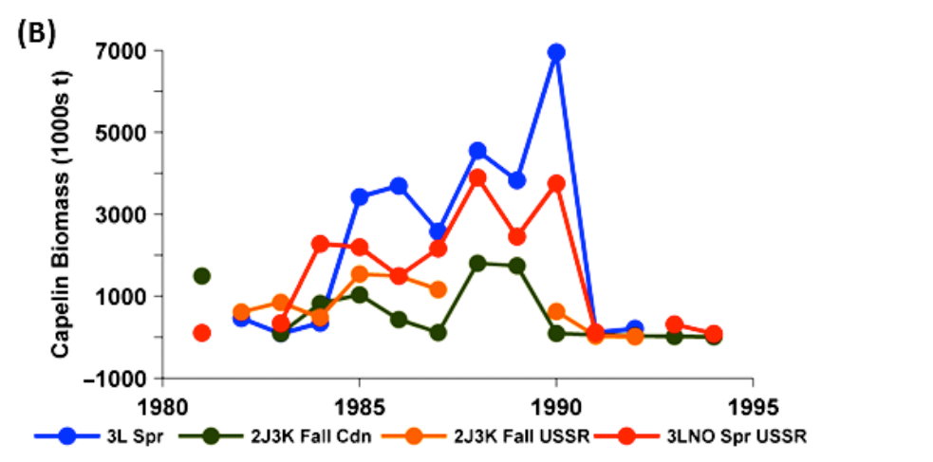

**Fig FM1 – Fig S1b taken from Frank et al.** Biomass estimates from capelin surveys in the NL region compared to the ongoing Div. 3L survey up to 1994.

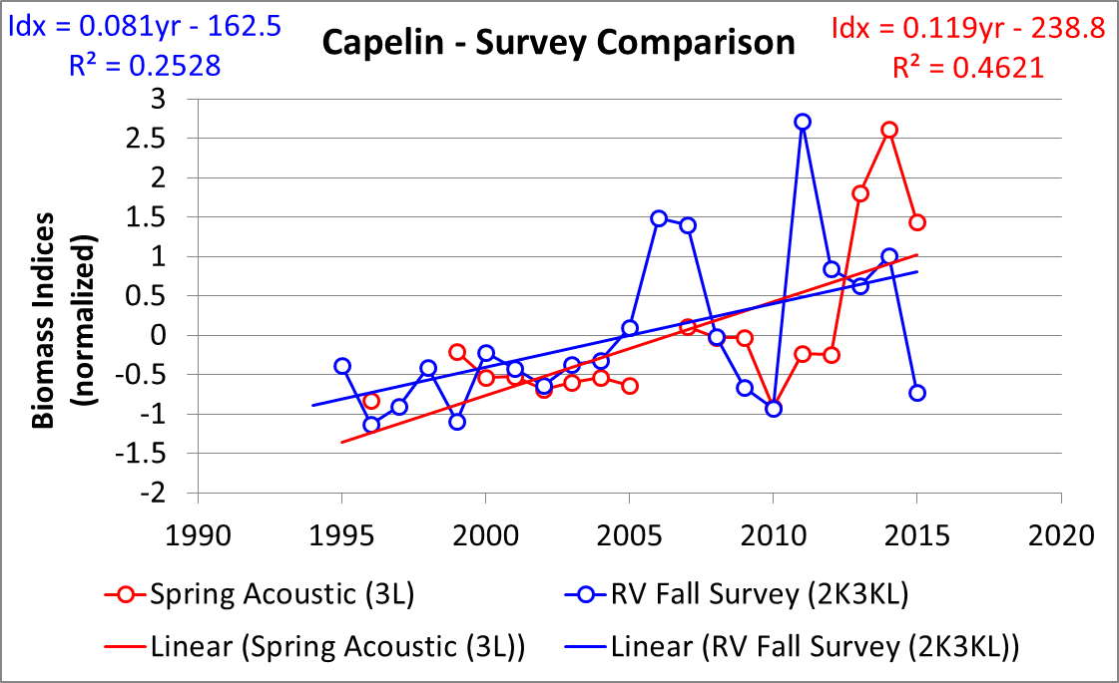

Fig FM2 – Temporal trends in spring acoustic and bottom trawl abundance estimates from 1995-2015.



Fig FM3 – Age composition by Nafo Division of capelin captured in fall 2J3K(L) acoustic surveys and in Campelen Fall 2J3KL bottom trawl surveys during period of different spring abundance index levels.

Figure FM4– Age composition of capelin found in the spring 3L acoustic survey from 1985-2015. Hatched bars indicate immature individuals. (2015 assessment excel)



**A**

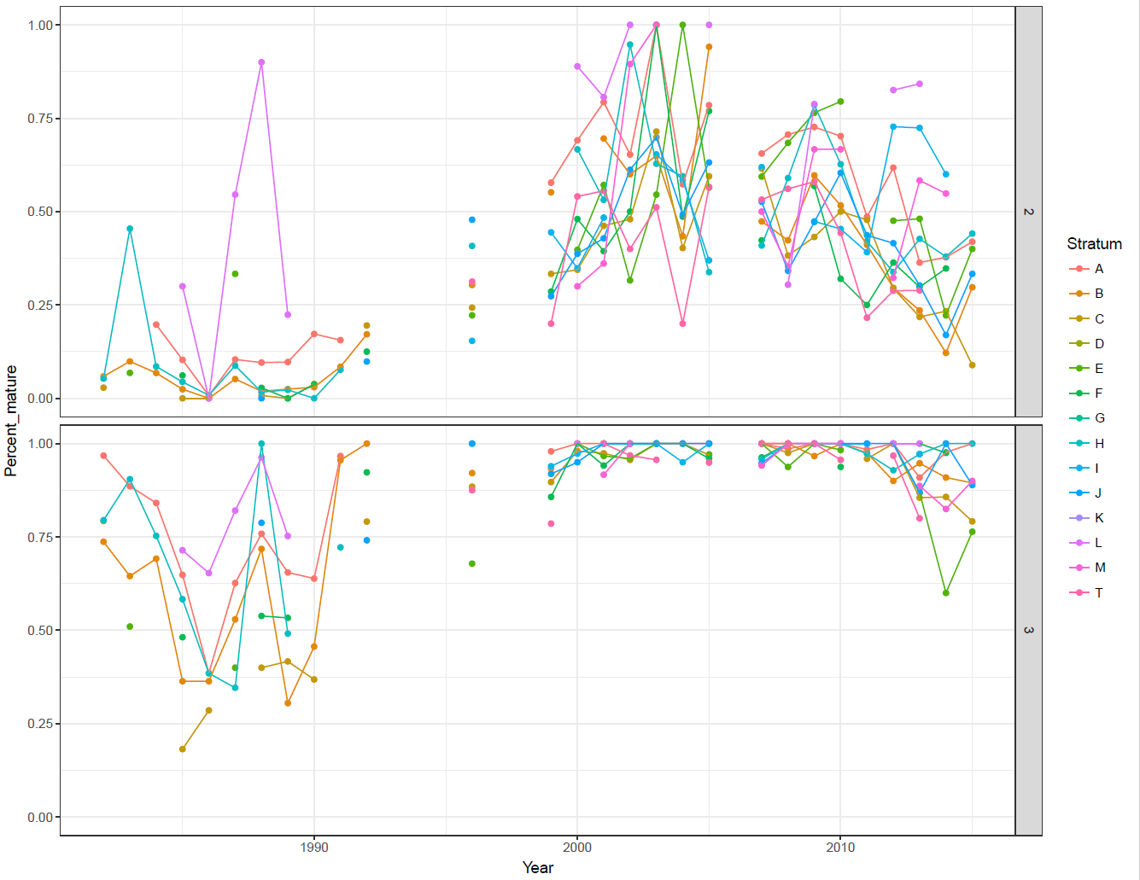

**B**

Figure FM5 - NAFO Division 3L with stratum boundaries used during spring acoustic capelin survey indicated (A); the proportion of maturing capelin by age (2- upper, 3 lower) and survey stratum as observed during surveys from 1982-2015 (**B**).



Figure FM-6 Inshore seasonal survey site Trinity Bay indicating the postion of acoustic transects (solid lines) and 100, 200 and 500 depth contours (dashed lines).

Figure FM-7 –Maturity stage composition (Upper) and age composition (lower) of capelin sampled in Trinity Bay during sesasonal surveys 2002 -2007.

Fig FM-8 Seasonal biomass trends in Trinity Bay May 2003-Sept 2005. Blue bars amounts in the main bay and red bars are those in the arms and bottom of the bay. May surveys of the main bay were conducted as part of the SOAS. There were no estimates of capelin in the Arms May surveys.

Figure FM-9 Offshore acoustic index (red diamonds) and Trinity Bay May acoustic index (blue diamonds) from May surveys conducted 1998-2017. Dashed grey line indicate 95% confidence limits indices.







Figure Age Composition Age composition of fish caught in the spring acoustic survey (top panel), and by the inshore commercial capelin fishery in Division 3K (middle panel) and Division 3L (bottom panel).



Figure Mortality Index of total mortality for capelin in Division 3L estimated from the spring acoustic surveys. Time series of the index are provided for capelin between ages 2 and 3, 3 and 4, 4 and 5, and 5 and 6. The time series for capelin between ages 1 and 2 is not shown as age-1 capelin are not fully recruited to the trawl gear. Note that values for 2010 over estimate the index of total mortality while values for 2011 under estimate the index as the 2010 survey had poor coverage of the capelin population and the abundances for the same cohorts a year later were somewhat higher.